SSS Srečanje 22.4.2021
TORRICELLIJEV POSKUS (Irena in Leoš Dvorak, Karlova Univerza v Pragi, projekt Heureka https://kdf.mff.cuni.cz/heureka/en/ )
- Irena used a garden hose of inner diameter about 2 cm.
- Normal water (neither cooked or degassed was used).
- Irena used clear water; she said that adding some tea could make the level of water more visible. (She uses tea in some small experiments, she did not use it for Torricelli.) Zdenek Drozd (from our department) uses a plexiglass tube attached to one end of the hose – the level of water is then clearly visible in it. However, it is not necessary, the level of water is visible also in the garden hose.
- The main “trick” is to pour the water to the hose from above and let the air bubbles go out – see the attached file. When you pour water slowly, the bubbles go out reasonably well. (I think you can help them by knocking to the hose from side but Irena says it is not necessary.) The bottom end of the hose should be closed firmly (hermetically). Then close the upper end and turn the hose upside down – see my (awful) drawings.

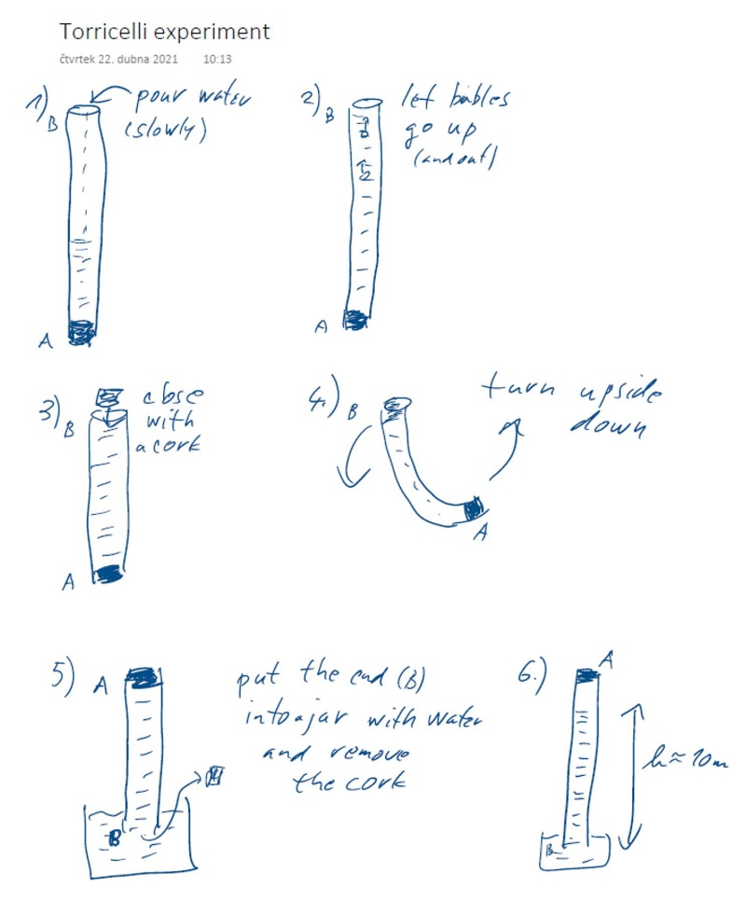
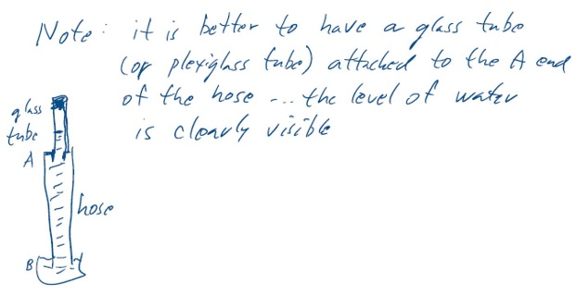

SVETLOBNI MLINČEK
Osnovni opazovalni poskus: https://youtu.be/JEqtkyPBMjE
Testni poskus: https://youtu.be/tF05edFE-MU

PLAZMA V MIKROVALOVNI PEČICI
https://youtu.be/Uix48Rm9S9U

NESTANDARDNA NALOGA IZ GEOMETRIJSKE OPTIKE
Spodnja skica kaže konveksno (zbiralno) lečo in točkasto svetilo, ki je postavljeno na geometrijsko os leče. Slika kaže dejansko velikost leče.
a. Z risanjem žarkovnih diagramov določite kaj od navedenega vidijo opazovalci, ki se nahajajo v točkah A, B in C: točkasto svetilo, sliko točkastega svetila ali nič od tega.
b. Ali obstaja takšno mesto iz katerega lahko opazovalec hkrati vidi točkasto svetilo in njegovo sliko? Če menite, da obstaja določite njeno mesto. Če menite, da ne obstaja, razložite zakaj tako mislite.

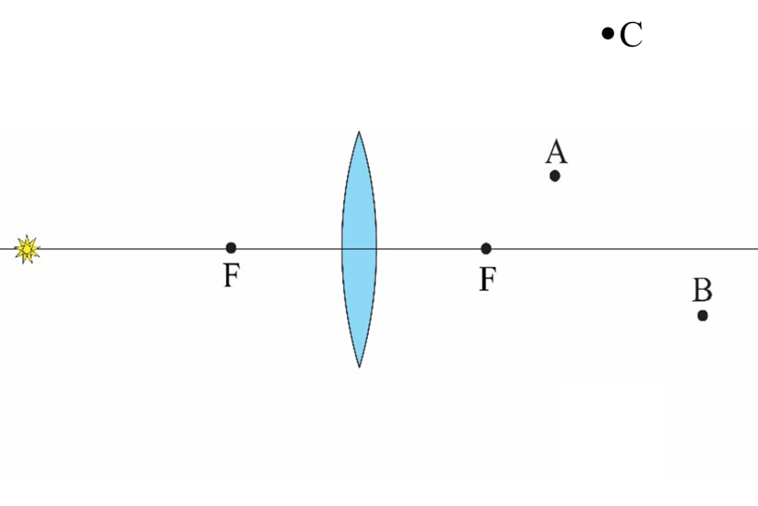
Najprej rešite nalogo, nato pa rešitev preverite s poskusom. Spodnja slika kaže preprosto postavitev poskusa.
